User's Manual for the Kinect Transformer ROS Package
Step One: Obtaining Files

A three-step process is used to execute the transformation and merging of a group of Kinect point clouds using the kinect_transformer ROS package. To obtain point file and image file snapshots from the Kinect, type the following command, accompanied by any combination of the listed optional command line arguments:
roslaunch kinect_transformer kinect_pts.launch
Argument Name | Description | Default Value
filename | The user-desired output file name. | test_cloud
y_rot | The rotational offset in degrees measured about the y axis. | 0
x | The translational offset along the x axis in meters. | 0
y | The translational offset along the y axis in meters. | 0
z | The translational offset along the z axis in meters. | 0
adjust | This can be set to 0 if you don't want the Kinect to use its motor to line itself up with the ground. | 1
pitch | This is the desired pitch angle of the Kinect. This argument can be set between 31 and -31 degrees, but is not guaranteed to be able to physically reach this. This argument does nothing if the adjust argument is disabled. | 0

As an example, the following command will log the file name and rotation about the y axis and create the files cloud1.pts and cloud1.bmp:
roslaunch kinect_transformer kinect_pts.launch filename:=cloud1 y_rot:=30
When the program is done acquiring a point set, it will prompt the user to press Ctrl+C to shut down the Kinect driver.
Step Two: Formatting the Information

After the program has been run to obtain points, two files are generated. One is a log file that contains a history of all the previous data acquisitions. This history includes the name that they were filed under, and the x and z angle measurements taken by the internal accelerometer of the Kinect.

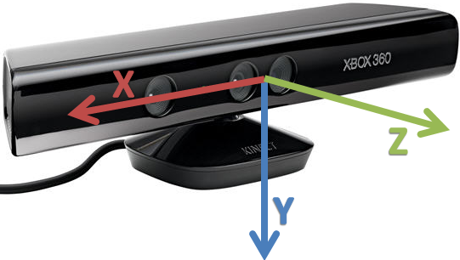

All of the other fields are set to their default values unless the user specifies their values at the command line. All translational and rotational parameters are measured from the desired root frame to the frame where the snapshot was taken.
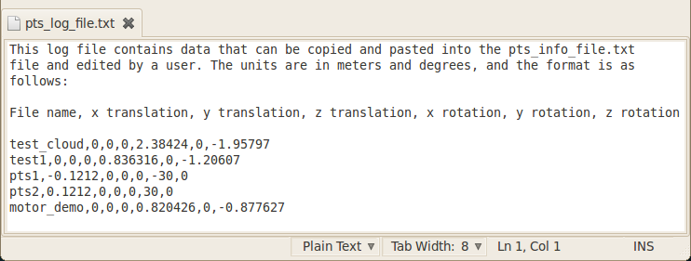
The other file is a points information file. This file is created the first time that a point file is created, and uses the first point file values as a placeholder. The info file should be edited to include all of the point clouds that a user wants to merge together. The format for the point cloud information is described in the log file and used in both the log file and the info file.
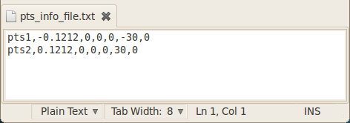
Step Three: Merging Files

Once the user is done preparing the information file, the following command runs the program that transforms and merges the points together:
roslaunch kinect_transformer kinect_transformer.launch
The following optional command line arguments can be used:
Argument Name | Description | Default Value
filename | The user-desired output file name. | output

The following example command will transform and merge all of the point files described in pts_info_file.txt and store the result in merged_cloud1.pts and merged_cloud1.wrl:
roslaunch kinect_transformer kinect_transformer.launch filename:=merged_cloud1
When the program is done, it will prompt the user to press Ctrl+C to shut down the ROS core of processes. After this three-step process is done, the programs will have generated information and log files in the package's root directory, and folders that contain individual point files, combined point files, VRML point files, and images of each individual snapshot.

